TO run the code compile javac Prob4GUI.java

To run Java Prob4GUI

1. The resulting graph does look like Figure 5

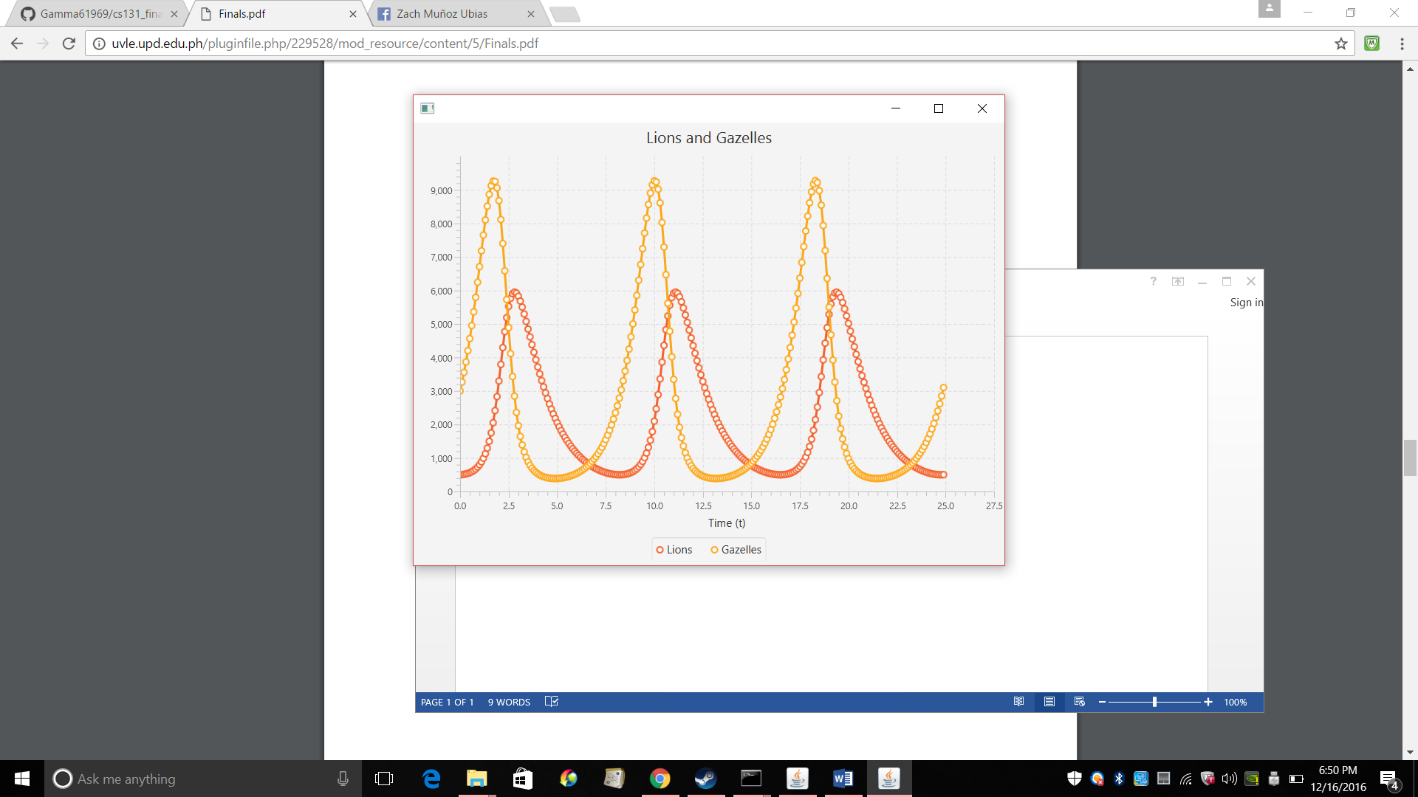

1. As the Population of the lions increases the Population of the Gazelles decrease and as the Population of the lion’s decrease the population of the gazelle’s increases. This is due to how the predator prey works. The predator once having a shortage of food, will have a decrease in their population due to starvation. The lesser predators around, the more gazelle’s will survive and grow thus having a similar to a sinusoidal function seen above.
2. IT looks like this

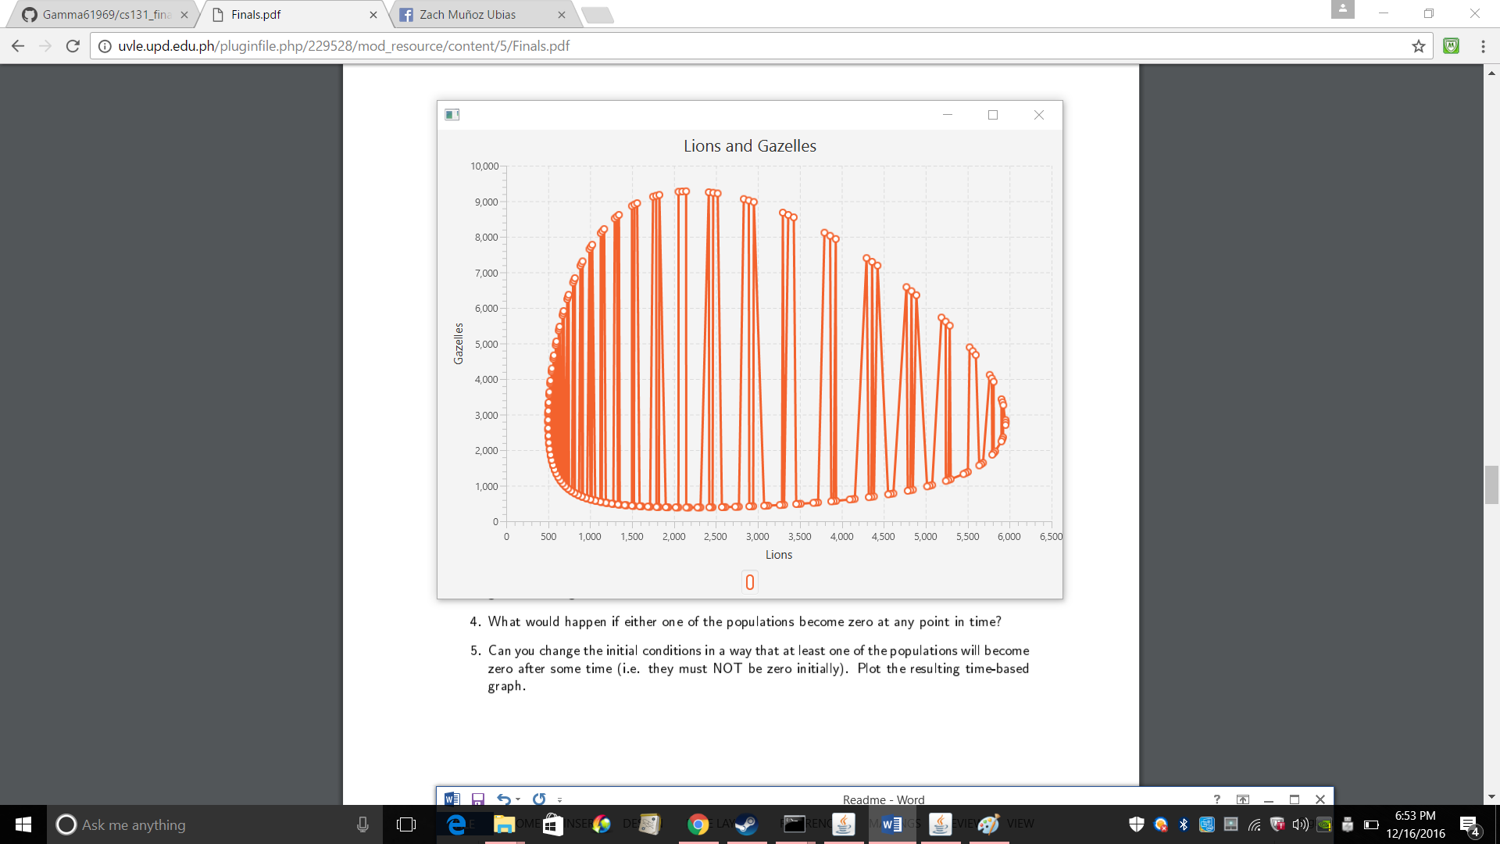

It looks like a distorted oblong. More or less a dinosaur egg.

1. If the Gazelle’s population becomes 0 the population of the lion’s will begin to decrease. However, if the population of the Lions at any time becomes 0 then the population of the Gazelles will increase
2. I made the initial values of lion = 1 and gazelle = 2 and it reaches decimal places with 0 on some points so as considered to be 0 and this is the result.

